Matthew Sparks 42602434

Whitney Tran 77187709

David Wong 22604337

Luke Duimovich 85341968

Daniel Williams 77402284

Ulises Perez 18374947

1. Introduction (Required)

We used ninjamock to design a mockup of our website. This tool was very helpful for iterating through our possible design schemas. It enabled us to easily test and develop our final product design which we were very efficiently able to change on the fly with guidance from our sponsor. We also used ER diagram tools to develop a simple schema for the backend database.

We made sure to design Schneiderman's Eight Golden Rules as much as possible into our design. (See number 8 for more information.)

2. Motivating Requirements (Optional)

Our designs are based off of a list of important data to capture given by our stakeholder. Our stakeholder has also included stretch goals for future implementations.

|  |  |
| --- | --- |
| Important Data to Capture | Stretch Goals / Nice-to-Haves |
| * Name * Year of Release * Main Platform * Genre(s) * Developer * Publisher * Box Shots * Screenshots | * Region * Media * Manual * Video (Twitch, Trailer, Gameplay (No Voice)) * Control Method * Main Character * Other Notable Characters * Other Available Platforms (linked, if possible) * Related Titles * *Synopsis (Possibly first column) * Others in Series * Interesting Info * Wiki Link * Aggregate Scores? * Many Others (UPC, Model #, # of Players) |

3. One or more UML class diagrams (Required)

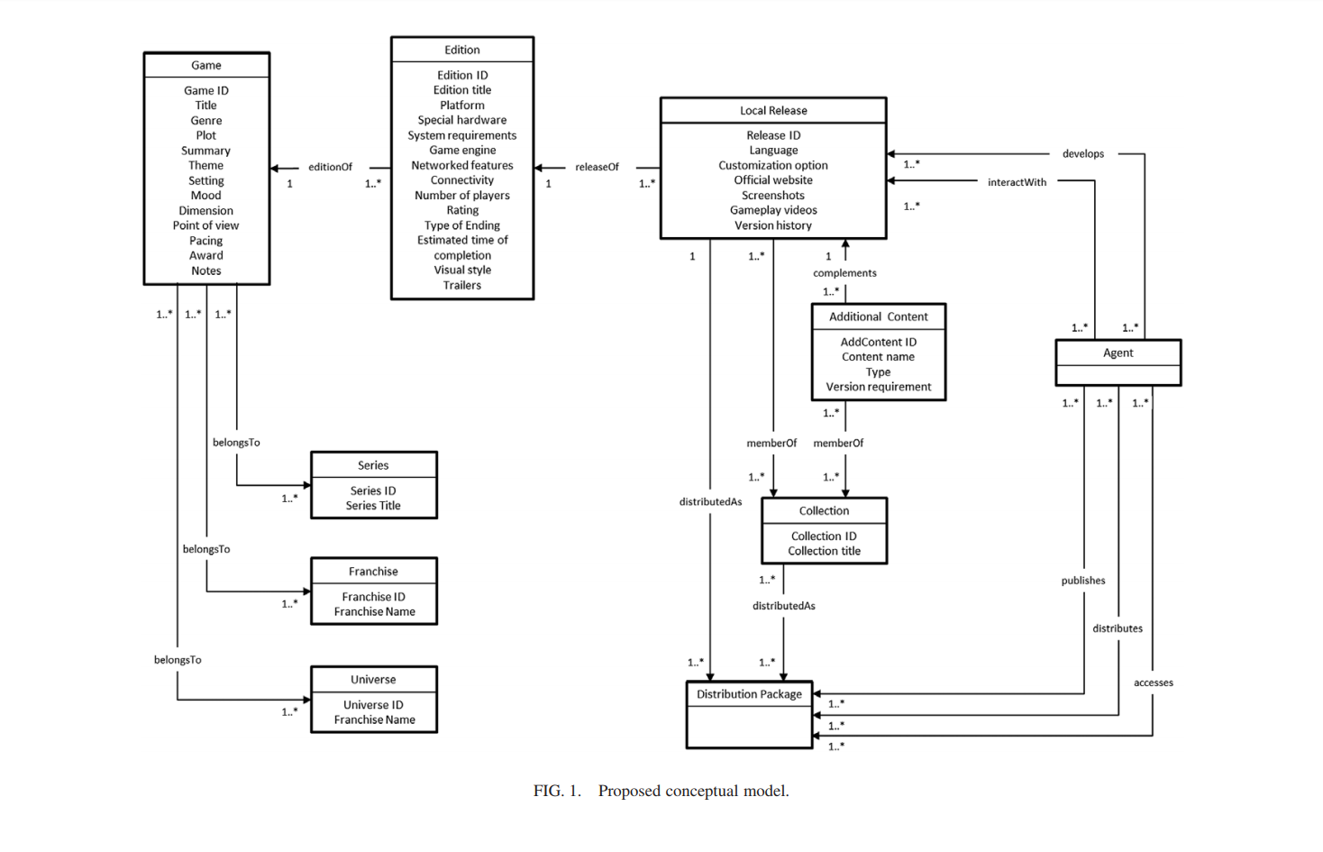

**6. UI/UX designs (Required)**

First Iterations of Mockups

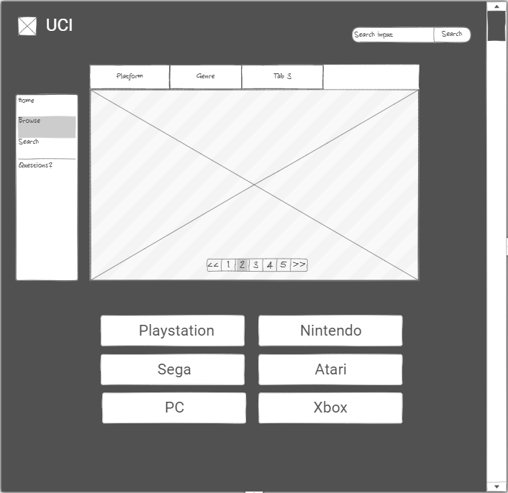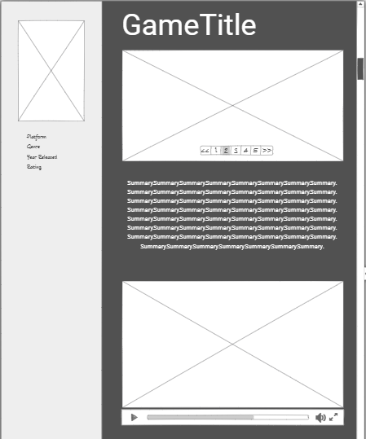

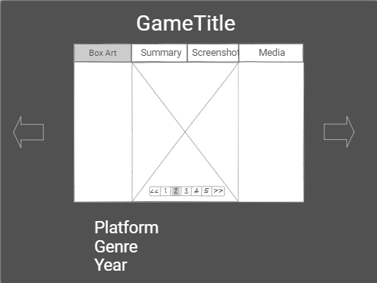 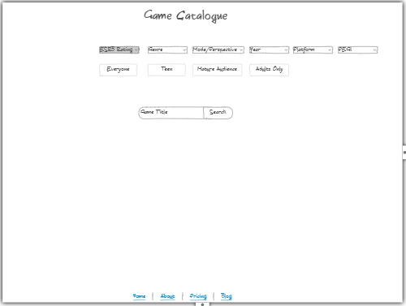

Approved Iterations of Mockups

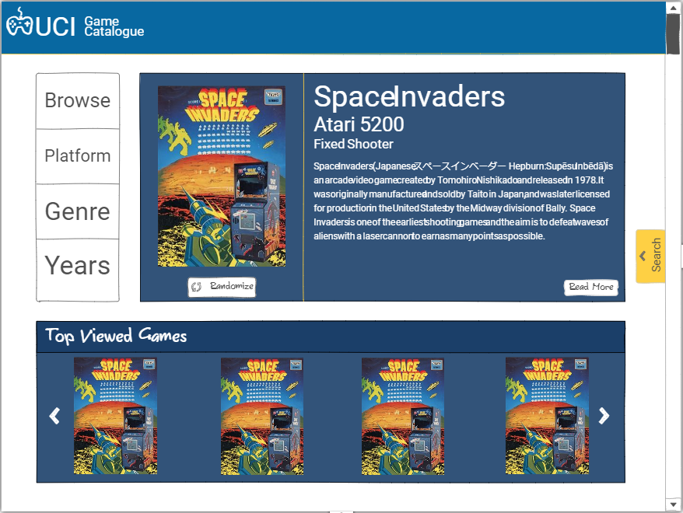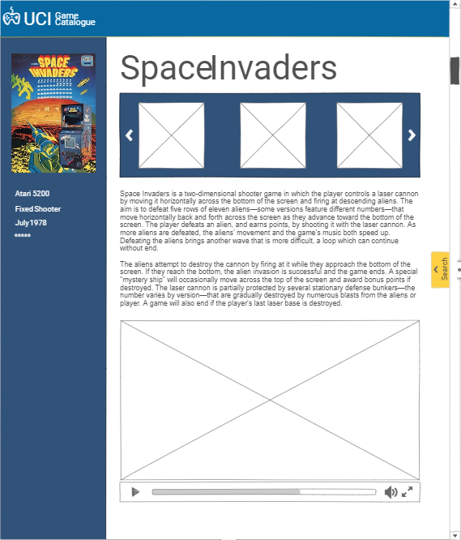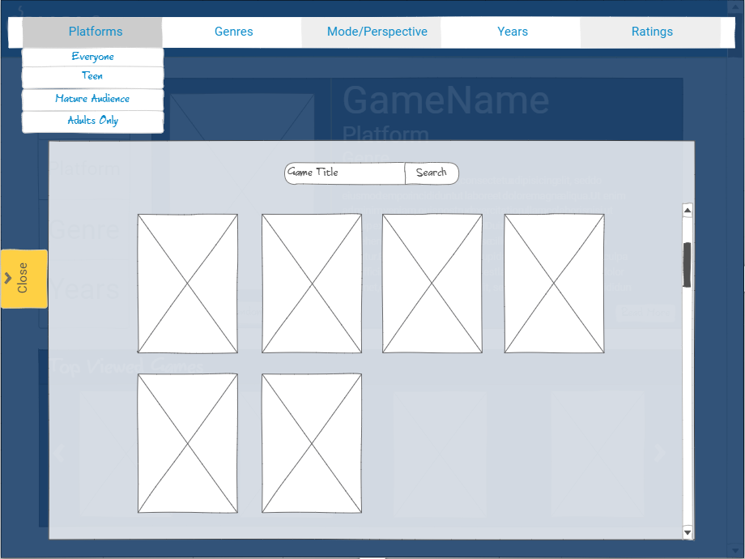

Implementation

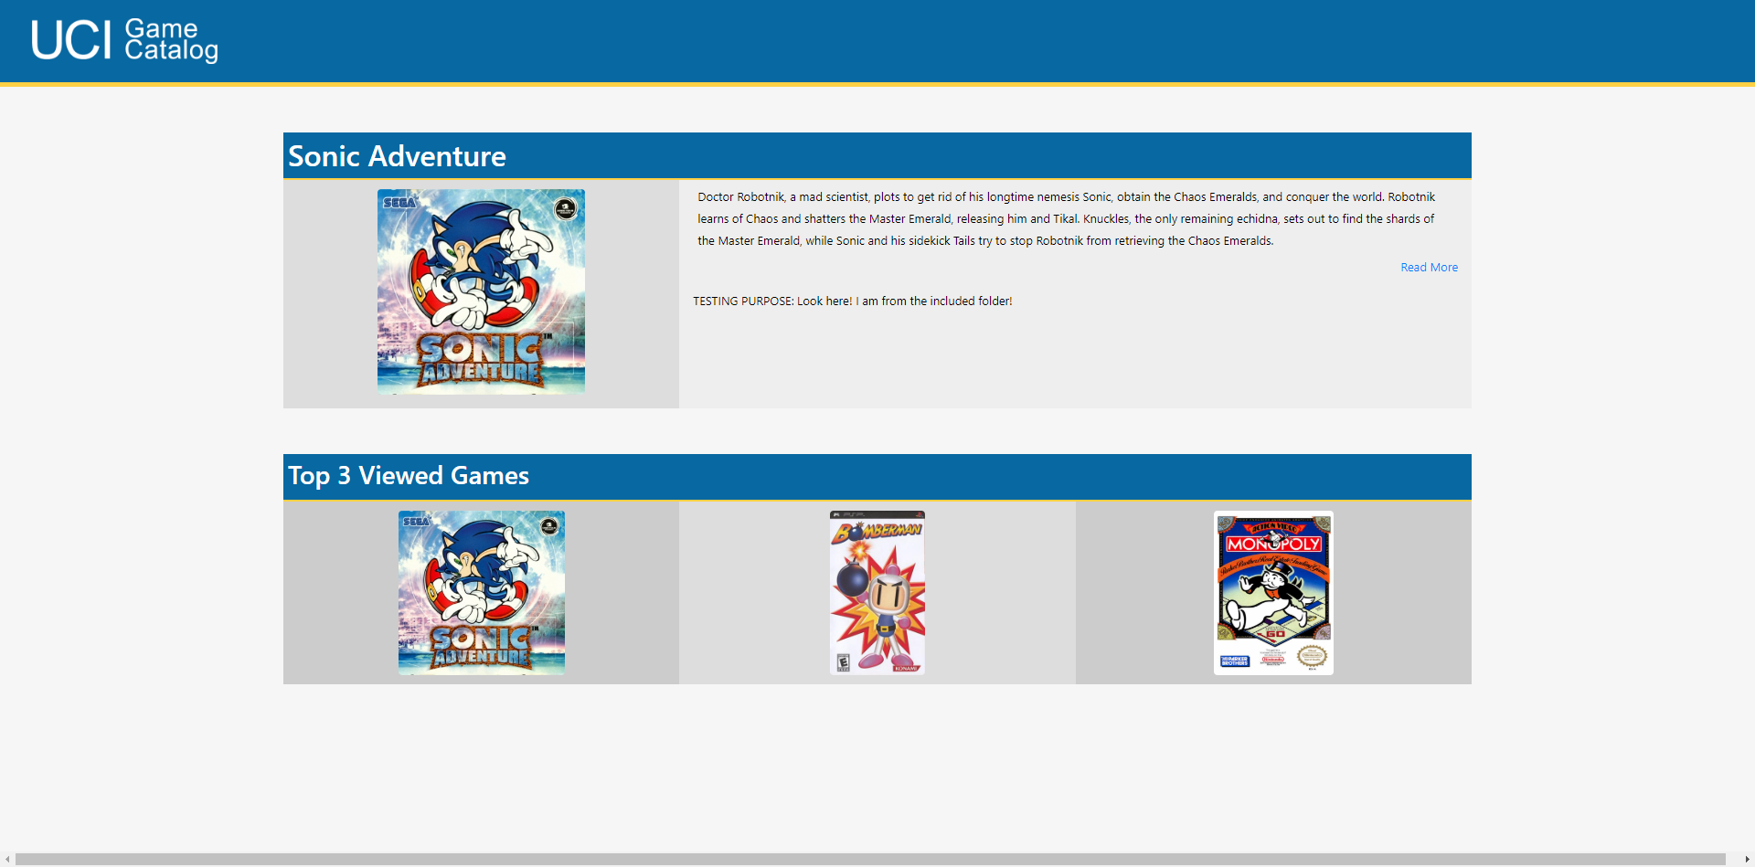

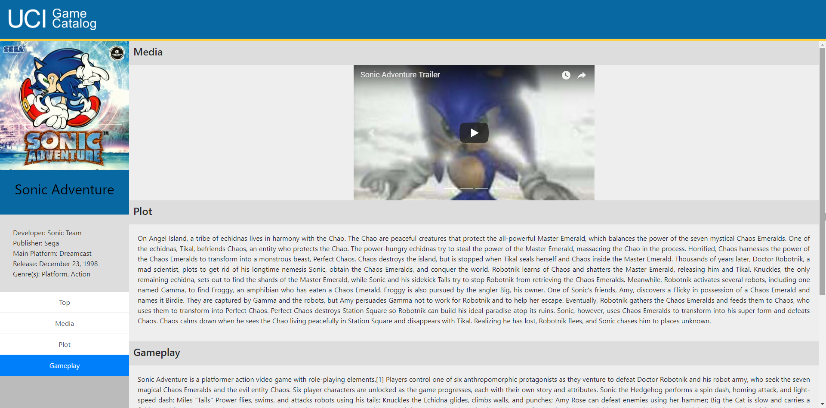

7. How did you apply specific design methods, such as Interviews, Observations, Focus

Groups, Personas, Scenarios, Site Maps, etc. (Optional)

We used cognitive walkthrough and a form of expert evaluation where we simulated being a user and walking through the site to see how it flowed. We also consulted and walked through with Professor Denenberg who has taught classes on software design and informatics. We made layout changes like broadening or expanding certain areas of the title screen, changing font, image positioning, sidebar size, game of the week position, and many other things.

8. How did you apply specific design principles or guidelines, such as covered in Discussion,

Nielsen design heuristics, etc. (Optional)

* **Strive for consistency**
  + We used similar frameworks for each page on our website and on each separate game page we expect the layout to stay the same.
* **Enable frequent users to use shortcuts**.
  + Instead of having to navigate all the way back to the home page we made the UCI Game Catalog Icon clickable which quickly and easily returns to the page. We made sure that if an object looked clickable that it was able to be clicked as well since that’s part of a good design. We also have other quick shortcuts for users who are familiar with the site like clicking game icons or a pop-up search bar.
* **Offer informative feedback.**
  + On every landing page we have in big bold letters what page it is for example Search page will have “search” in big letters at the top and it is the same for each game page. We also will have an eyeglass symbol at the top of the page for the search bar as well as the words search in light grey to offer simple feedback to the user informing them it is in fact a search bar.
* **Design dialogs to yield closure.**
  + We plan on having a loading icon for when the user is searching for a page but may not have time to implement.
* **Offer simple error handling.**
  + When the user searches for a game and it is not found a simple screen will show up that says something along the lines of “Game not found; try modifying your search.”
* **Permit easy reversal of actions.** 
  + There will be back buttons on each page and multiple ways to return to the home screen. We will also have the search bar present on every page so it eliminates the necessity of having to reverse certain actions.
* **Support internal locus of control.** 
  + Whatever the user clicks on the page will load the appropriate pages, or perform the appropriate actions, therefore keeping the user in control of the site. E.G. Search will lead to search results, Read More will lead to more info about a game
* **Reduce short-term memory load.**
  + Memory load will be reduced by clear labels of buttons, so the user can use these to navigate between the various pages easily. For example, on the navigation bar there is a “home” button that will take the user to the home page.

9. Summary or Conclusion or Future design implications/suggestions (Required, but only

one of three options)

Throughout the design process we have used the previous methods to build on each other and move closer to our goal of completing the website. It started with sketches/mockups, which the team came up with and used that as the base for ideas on the layout of the website. We used the mockups to make a better looking design that we could present to our sponsor and make adjustments to the design before moving into implementation. Once we finalized the designs, we used the wireframes created and started the implementation of the code on the front and back end to mirror our intended design. The front end was implemented through HTML and Python/Django framework. The back end is a database using MySQL, which is using various resources to supply the needed information the site requires.